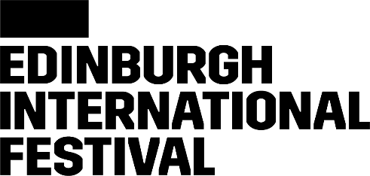

FOOD
Audio Introduction: Transcription

Tom: This is the Edinburgh International Festival podcast, All You Need to Know. I'm Tom Service. This time, Geoff Sobelle's FOOD. We're going to hear from Geoff Sobelle himself on this absolutely unique show and production. But first, here's Festival Director, Nicola Benedetti.
Nicola: I mean, who wouldn't want to go to this? Like, [chuckles] FOOD.
Tom: A dinner table, food happening, performance, music, right? Everything.
Nicola: Exactly.
Tom: Multisensory.
Nicola: But the deeper underlying point of our conscience and consciousness around what we eat and where it comes from and what we have versus what we actually need, the entire ecosystem and backstory to how food gets on our plate and-and the choices that we make around food, especially, and in a world where our connection to its journey and story is so disconnected, thought-provoking, humorous, something only Geoff Sobelle could create and pull off.
Geoff: My name is Geoff Sobelle, and I'm an American theatre artist and performer. The show is called FOOD, and the subject matter is as basic as the title. When I was thinking about a new piece to make, I had a number of ideas, and this was just the one I started tinkering with first. So, FOOD. I really love these subjects that are so simple and yet so huge you could never really begin to wrap your arms around them.
I think it feels kind of monumental or something when it's all in capitals, you know. It's like, FOOD, like, here we go, like very important or something like that. [chuckles] I don't know. It's not like dinner or, "Would you like some breakfast?" "How about some lunch?" Or, "Would you like a snack?" It's like, FOOD. It's like all the things, and so I think it kind of asks you to think what feeds you, but also what feeds the food that you eat and what is food?
The actors are me, so I'm the only performer, but the space and the light is shared between myself and the audience pretty generously. The staging of it is that you are invited to sit around a very large dinner table of sorts. White linen tablecloth, chandeliers, that kind of thing. The rest falls out from there. The things that I'm curious about are both how you bring flavors, smells, sensations, how these things are so personal, I suppose, and where they come from, whether that be family or culture, and what culture even means, like whether that's culture at large or culture really on a small level.
I'm super interested in us as animals and how we use our nose and why and why not. I have many favorite moments, but-- uh, some that I can't disclose, but I think the thing that I would like to disclose, it's really the moment when people take each other in. That's to me the most exciting. When they look around and they realise that they are both to see and to be seen, that it's not a kind of show where there's a performer who's gonna really do things for them to-- for their entertainment, rather it's about the room, that's an exciting moment.
Tom: Geoff Sobelle and Nicola Benedetti. FOOD is on from the 3rd to the 27th of August at The Studio. This is the European premiere of a production so delicious, you're gonna want to enjoy it again and again throughout this year's Edinburgh International Festival, Geoff Sobelle's FOOD. And we'd like to thank Sir Ewan and Lady Brown for supporting FOOD.

