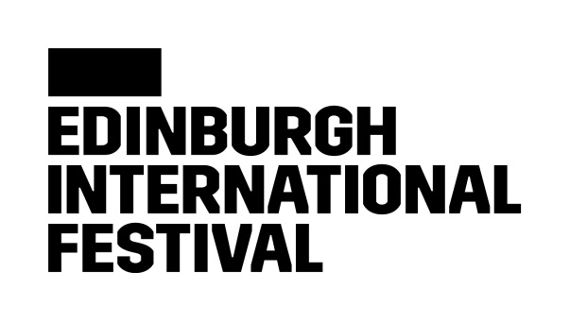

We are committed to delivering an unparalleled celebration of the performing arts, which brings some of the most exciting and creative artists working today to audiences from around the world.

**Media Officer**

The Edinburgh International Festival is looking for an experienced, passionate and dedicated Media Officer to join the team. As part of the Communications team, the Media Officer will develop and implement effective media campaigns and continue to grow the Festival’s media presence in a vibrant arts landscape.  **Edinburgh International Festival Equality and Diversity Commitment**

The Edinburgh International Festival is an equal opportunity employer, and we value diversity. We believe that an inclusive culture is the foundation for a successful workplace, and we strive to grow our diverse representation across our staff, our artists, and our audiences.

We are collecting data to measure the effectiveness of our recruitment methods, to ensure that they are fair. We strive to ensure our opportunities are accessible to people from all backgrounds.

We actively encourage applications from currently under-represented groups. We have identified ethnic minority backgrounds, and disabilities as the key areas we would like to focus our recruitment efforts in.

**Disability Confident Employer**

We’re committed to creating a workplace where everyone feels like they belong. We want to make our recruitment practices as inclusive and fair as possible, and as part of that, we have joined the Disability Confident scheme, this is a government scheme designed to help us make the most of the talents of those with disabilities and/or health conditions in the workplace. All applicants with a disability who meet the minimum requirements of the job as set out in the job description are guaranteed an interview.

**Rooney Rule**

We are building a Festival team that is able to understand the needs of and effectively communicate with the whole of our diverse community. We want our team to reflect the diversity of the wider population. This includes the representation of people from ethnic minority backgrounds and we apply the Rooney Rule to achieve this.

Adapted from American football, this is a form of positive action. We recognise that our workforce does not reflect our wider communities, in terms of people from ethnic minority backgrounds. Subject to consent from our equality and diversity form in Team Details, out of the candidates who meet the essential selection criteria for the role and who are from an ethnic minority background, at least one will be shortlisted for the next stage in the recruitment process, which is usually an interview.

**Role -** Media Officer

**Manager –** Media Manager

**Department** – Communications and Digital Team, Audiences Department

**Job Purpose -**

To promote the International Festival to a broad range of media, in line with the overall communications strategy, and to act as a central liaison between artists, agencies, media and staff.

## **Responsibilities**

Initiate, maintain and develop positive relationships with press and media contacts across Scotland, the UK and internationally.

Devise and implement targeted media campaigns across online, print and broadcast media in collaboration with the Media Manager and in line with the overall communications and audience strategies.

Develop and pitch stories, news and features which support key messages, working closely with the wider Communications & Digital team and agency partners.

Liaise with artists, staff, agencies and media in setting up and supervising interviews, preview trips and broadcast opportunities.

Research, write and disseminate a range of materials for media, including op-eds, press releases, notes and pitches.

Manage and track the media partnership deliverables for the Festival.

Provide relevant images, videos and information to media as required, and to maintain clear asset and information filing systems.

Co-ordinate media calls and functions as required.

Manage the internal communications output of the Communications team, including media coverage and the international communications newsletter.

Supported by temporary Communications staff during peak periods, monitor daily media output, circulating, logging and reporting on coverage across all media. This will include working with digital and print monitoring systems, and other systems as needed.

To support the Media Manager and Head of Communications & Digital in carrying out the functions of the Festival Press Office as required.

Represent the Edinburgh International Festival at public events as required.

Any other tasks as required to support the Audiences department.

**Person specification**

**Essential**

A knowledge of and passion for the live performing arts

At least two years’ experience or equivalent in media and communications work, with a proven track record in delivering press coverage

Knowledge of, and good relationships with, current UK arts journalists

Excellent communication skills, both verbal and written

Adept at using software including the Microsoft Office suite and Google Docs

Excellent organisational and time management skills

**Desirable**

Knowledge of and enthusiasm for classical music

Knowledge of and experience working with key international media

Experience of using the Roxhill media database, Artifax, Monday.com and Meltwater media monitoring system

Experience working within an arts organisation or festival

**Terms and Conditions**

**Working days/hours** 35 hours per week, by agreement within standard office hours of 9.30 to 17.30, Monday to Friday. At peak times, and particularly immediately before and during the International Festival, it will be necessary to work outside standard hours and at weekends.

**Working arrangements** We are located in Edinburgh, where all roles are based. To support flexibility we have a Smarter working policy, and are open to discussions as we move through the recruitment process, please do not hesitate to ask any questions.

**Contract type** Permanent contract,

**Salary range** £25,000 - £27,000

**Holiday entitlement** 25 days per annum (with 3 days requiring to be taken between Christmas and New Year) plus 10 days public holiday, 5 days are fixed and 5 floating days.

**Pension Scheme** The International Festival will comply with the employer pension duties in accordance with Part 1 of the Pension Act 2008, as amended or replaced from time to time.