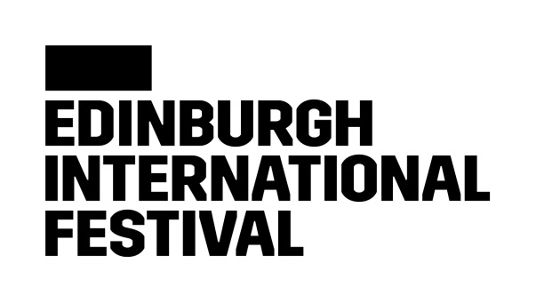

We are committed to delivering an unparalleled celebration of the performing arts, which brings some of the most exciting and creative artists working today to audiences from around the world.

**Media Assistant**

**Administrative support for the publicity functions of the International Festival, and support for the Audiences Team in the promotion of the Edinburgh International Festival brand and programme.**

**Edinburgh International Festival Equality and Diversity Commitment**

The Edinburgh International Festival is an equal opportunity employer, and we value diversity. We believe that an inclusive culture is the foundation for a successful workplace, and we strive to grow our diverse representation across our staff, our artists, and our audiences.

We are collecting data to measure the effectiveness of our recruitment methods, to ensure that they are fair. We strive to ensure our opportunities are accessible to people from all backgrounds.

We actively encourage applications from currently under-represented groups. We have identified ethnic minority backgrounds, and disabilities as the key areas we would like to focus our recruitment efforts in.

**Disability Confident Employer**

We’re committed to creating a workplace where everyone feels like they belong. We want to make our recruitment practices as inclusive and fair as possible, and as part of that, we have joined the Disability Confident scheme, this is a government scheme designed to help us make the most of the talents of those with disabilities and/or health conditions in the workplace. All applicants with a disability who meet the minimum requirements of the job as set out in the job description are guaranteed an interview.

**Rooney Rule**

We are building a Festival team that is able to understand the needs of and effectively communicate with the whole of our diverse community. We want our team to reflect the diversity of the wider population. This includes the representation of people from ethnic minority backgrounds and we apply the Rooney Rule to achieve this.

Adapted from American football, this is a form of positive action. We recognise that our workforce does not reflect our wider communities, in terms of people from ethnic minority backgrounds. Subject to consent from our equality and diversity form in Team Details, out of the candidates who meet the essential selection criteria for the role and who are from an ethnic minority background, at least one will be shortlisted for the next stage in the recruitment process, which is usually an interview.

**Job Title: Media Assistant**

**Manager: Media Manager**

**Department: Audiences**

**Job Purpose:**

Administrative support for the publicity functions of the International Festival, and support for the Audiences Team in the promotion of the Edinburgh International Festival brand and programme.

**Responsibilities**

* Monitor daily media output, circulating, logging and reporting on coverage across all media. This will include working with digital and print monitoring systems, and other systems as needed.
* Collate, record and regularly communicate approved content and social output to wider Festival team as part of the weekly communications update.
* Provide relevant images, videos and information to media as required, and to maintain clear asset and information filing systems.
* Use appropriate platform analytics to monitor and record press reporting stats.
* Support the Media Manager and Media Officer in carrying out the functions of the Festival press office as required.
* Work closely with the Media Manager on the management of press tickets.
* Brainstorm and generate content ideas with Audiences team, contributing to campaign planning.
* Support the work of the wider Audiences team as required.
* To assist at photo calls, media calls, press conferences and functions as required.
* General support of communications activity across the International Festival season

**Person Specification**

* Must have an interest in media and communications work, and some experience in the area is preferred
* Proven experience of working in a fast-paced environment with the ability to prioritise a conflicting workload
* Excellent copywriting and communication skills are essential
* Must have excellent organisational and administrative skills
* A knowledge and passion for the arts is essential and an interest in classical music is a plus

**Terms and Conditions**

**Working days/hours** 35 hours per week, by agreement within standard office hours of 9.30 to 17.30, Monday to Friday. At peak times, and particularly immediately before and during the International Festival, it will be necessary to work outside standard hours and at weekends.

**Working arrangements** We are located in Edinburgh, where all roles are based. To support flexibility we have a Smarter working policy, and are open to discussions as we move through the recruitment process, please do not hesitate to ask any questions.

**Contract type** Temporary contract, 5 May to 5 September 2025

**Salary**  £23,400-25,000 per annum pro rata

**Holiday entitlement** 25 days per annum (with 3 days requiring to be taken between Christmas and New Year) plus 10 days public holiday, 5 days are fixed and 5 floating days.

**Pension Scheme** The International Festival will comply with the employer pension duties in accordance with Part 1 of the Pension Act 2008, as amended or replaced from time to time.

As a result of the current immigration rules, these roles are not eligible under the Skilled Worker Route. Job applicants will be expected to provide evidence of right to work in the United Kingdom or be able to obtain such.