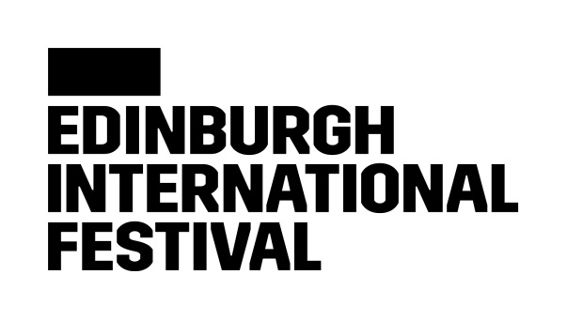

**Introduction**

The Edinburgh International Festival is an unparalleled celebration of the performing arts and an annual meeting point for peoples of all nations. With a deep commitment to virtuosity and originality the International Festival presents some of the finest performers and ensembles from the worlds of dance, opera, music and theatre for three weeks in August.

Over the course of the year, the International Festival team travels the world to bring together an unrivalled programme of the most exciting and creative artists working today. Together, we present unique collaborations, world premieres, new interpretations on classic works, critically acclaimed productions and more – that thrill, move, excite and entertain audiences from around the world. All in one place, right here in Scotland.

One of the world’s most beautiful and historic cities, Scotland’s capital is transformed into a rich, bubbling melting pot of creative talent, where every day and night offers exciting possibilities to make new discoveries or catch some of the biggest names in the performing arts on stages and in concert halls across the city.

We are committed to enriching people’s lives through the arts and contribute to the cultural and social life of the City of Edinburgh and of Scotland. Our programmes of community engagement, professional development and creative learning for young people run throughout the year, reaching the widest possible audiences.

Compelling, exciting and often surprising, the International Festival is, quite simply, an unmissable experience.

We believe that being inclusive and diverse across all areas of our work helps us bring the best international festival to Edinburgh. We welcome and encourage job applications from people of all backgrounds. Please let us know in your application if you would like to consider job sharing for this role.



Job Title Head of Staging [Fixed Term-Seasonal]

Reports to **Head of Production**

Works with **Production department, Visiting Companies**

Job Purpose **To oversee and deliver on all Staging factors across all productions for the annual Edinburgh International Festival.**

**Responsibilities**

* Overseeing all staging elements for all productions invited to perform at Edinburgh International Festival. Including Scenic installs, construction, Stage preparation, Rigging, Workshop and equipment distribution.
* Sourcing and managing a suitable Core Staff Team in the area of Staging.
* Managing and scheduling the department carpenters, drivers, and workshop staff.
* Negotiating hire and supply of all staging equipment required for visiting companies.
* Managing the carpentry department to ensure scenic build requirements are clearly communicated.
* Sourcing of staging and scenic elements as required.
* Ensure the appropriate and safe storage of materials and resources.
* Working with the other departments to ensure ground plans are kept up to date.
* Ensure that appropriate codes of practice and current regulations are adhered to.
* Ensure departmental input at all related design, production and planning meetings.
* Liaising with EIF venue staff about show information and requirements.
* Financial management of department spending in agreement with Head of Production.
* Confidently represent the International Festival’s core brand values and personality in all areas of your work.
* Ensure that the department works within agreed parameters concerning hours and breaks.
* Attend management and other meetings as required.
* Any other duties as agreed by the Head of Production.

**Person specification**

**Essential**

* Good team worker
* Good at working under pressure
* Excellent written & verbal communication
* Excellent time keeping and an ability to deliver to a strict time scale
* Experience working in the Theatrical, Events and Live Performance industries.
* Experience of leading and managing teams in a supervisory or managerial position
* Experience working on large scale and international productions.
* Working knowledge of current legislation regarding Staging and Rigging or equivalent
* Safe and proper use of tools and machinery
* Excellent logical troubleshooting skills
* Flexible attitude to anti-social working hours as required by the post, including evenings, overnights, and weekends.
* Experience of manual handling
* Experience of preparation of work schedules & medium-term staff rotas
* Full or automatic UK driving license
* Attention to detail and an ability to work on multiple projects simultaneously.
* Good administrative and IT skills.
* Proficiency with Vectorworks or similar CAD Package
* Self-motivated and organised.

**Desirable**

* Financial and budget managing experience
* Good knowledge of sector suppliers and resources
* Basic carpentry and metal work skills
* MEWP licence
* PASMA licence
* First Aid qualification
* Experience in other theatre disciplines.
* An understanding of the needs of supporting the entire programme for the Edinburgh International Festival
* Experience Working at Height

**Terms and Conditions**

Working days/hours Due to the nature of the Festival you will be expected to work such hours as necessary to carry out the role. All hours are to be agreed with the Head of Production.

Contract type Fixed Term Seasonal (May 2025 until Setpmber 2025)

Salary £44’000- £48’000 pro-rata.

Holiday entitlement12.1% of hours worked

Pension SchemeThe Edinburgh International Festival will comply with the employer pension duties in accordance with Part 1 of the Pension Act 2008, as amended or replaced from time to time.

As a result of the current immigration rules, these roles are not eligible under the Skilled Worker Route. Job applicants will be expected to provide evidence of right to work in the United Kingdom or be able to obtain such.