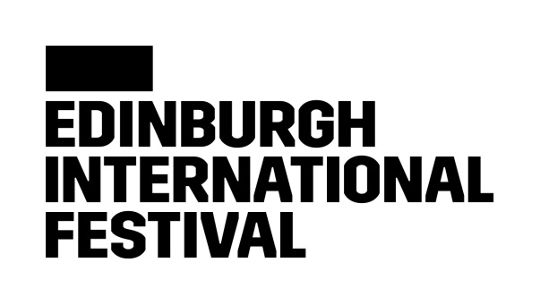

We are committed to delivering an unparalleled celebration of the performing arts, which brings some of the most exciting and creative artists working today to audiences from around the world.

**Community & Access Officer**

We are looking for a passionate, positive and proactive person who thrives on connection with people and working collaboratively, to support the delivery of the Community Connections programme and the Festival’s Access initiatives. This includes working across a variety of projects, workshops, resources and events as part of the wider Audience’s Department strategy, enshrining accessible practices and inclusion.

This post includes working with communities, organisations, individuals and artists across Edinburgh, Scotland and internationally.

**Edinburgh International Festival Equality and Diversity Commitment**

The Edinburgh International Festival is an equal opportunity employer, and we value diversity. We believe that an inclusive culture is the foundation for a successful workplace, and we strive to grow our diverse representation across our staff, our artists, and our audiences.

We are collecting data to measure the effectiveness of our recruitment methods, to ensure that they are fair. We strive to ensure our opportunities are accessible to people from all backgrounds.

We actively encourage applications from currently under-represented groups. We have identified ethnic minority backgrounds, and disabilities as the key areas we would like to focus our recruitment efforts in.

**Disability Confident Employer**

We’re committed to creating a workplace where everyone feels like they belong. We want to make our recruitment practices as inclusive and fair as possible, and as part of that, we have joined the Disability Confident scheme, this is a government scheme designed to help us make the most of the talents of those with disabilities and/or health conditions in the workplace. All applicants with a disability who meet the minimum requirements of the job as set out in the job description are guaranteed an interview.

**Rooney Rule**

We are building a Festival team that is able to understand the needs of and effectively communicate with the whole of our diverse community. We want our team to reflect the diversity of the wider population. This includes the representation of people from ethnic minority backgrounds and we apply the Rooney Rule to achieve this.

Adapted from American football, this is a form of positive action. We recognise that our workforce does not reflect our wider communities, in terms of people from ethnic minority backgrounds. Subject to consent from our equality and diversity form in Team Details, out of the candidates who meet the essential selection criteria for the role and who are from an ethnic minority background, at least one will be shortlisted for the next stage in the recruitment process, which is usually an interview.

**Job Title** Community & Access Officer

**Reports to**  Community Connections Manager & Access Manager

**Department Lead** Head of Discovery & Participation

**Works with** Discovery & Participation Team, Audience Experience Team, Audiences Department, and wider Festival teams.

**Job Purpose** To support the delivery of the Community Connections programme and International Festival’s Access initiatives, including projects, workshops, resources and events as part of the wider Audience’s Department strategy, enshrining accessible practices and inclusion.

This post includes working with communities, organisations, individuals and artists across Edinburgh, Scotland and internationally.

**Responsibilities**

* Collaborate with and support the Community Connections Manager and Access Manager to design and deliver programmes which create accessible and impactful connections between the International Festival and local communities, including pop-up performances, workshops, skills development initiatives and discussion events.
* Contribute to the ongoing development of a Community Connections plan that demonstrates clear impact in line with the International Festival’s strategic aims.
* Work with the Access Manager on our Access initiatives including; delivery of programme of accessible performances; distribute access-specific marketing materials, implement procedures to further remove barriers for audiences.
* Communicate positively and proactively, growing the Festival’s network and building relationships with project participants, community/access organisations, freelancers and audiences.
* Facilitate and lead project workshops, focus groups and presentations
* Work collaboratively with the Youth Connections team to make the best possible use of knowledge and resources across the Discovery & Participation programmes, particularly around intergenerational and accessible experiences.
* Work with the wider Audiences department, devising ways to connect with and welcome people who have never experienced the Festival before, ensuring they have the best possible first-time experience.
* Report to the Community Connections Manager and Access Manager on project budgets, timelines, risk mitigation and ledger management
* Report on activity and collect relevant participation data and feedback. Contribute to the debrief process and ensure all end of project reporting is presented in a clear and compelling way.
* Confidently represent the International Festival’s values and vision in all areas of your work.

Any other duties as may reasonably be required 

## **Person Profile**

The successful candidate will be passionate, positive, and proactive. We are looking for someone with creative project delivery experience, who thrives on connecting with people and working collaboratively. Articulate and numerate, with warm interpersonal and communication skills.

**Essential**

* At least 2 years demonstrable experience of creating, implementing and documenting community-based activities and building relationships with a range of partners.
* A clear understanding of the communities that the postholder will engage with through this portfolio of work, particularly diverse communities across Edinburgh and D/deaf, disabled and neurodivergent people.
* A passion for the performing arts and the power of creative learning and engagement
* Excellent facilitation and presentation skills
* A confident and warm communicator
* Excellent problem solving, organisational, and time management skills.
* Administration and project management skills
* Excellent numeracy and written skills, including use of Microsoft software packages

The post holder must be a member, or eligible to become a member of Disclosure Scotland PVG scheme.

**Desirable:**

* An enthusiasm for the core artforms of the Edinburgh International Festival, particularly classical music
* Specific experience of working with groups of people with protected characteristics
* Experience in organising and delivering creative projects in community settings
* An active interest and knowledge of the work of the Edinburgh International Festival and a wider understanding of the Edinburgh Festivals
* Knowledge and experience of Scottish and/or international arts sector
* Knowledge and experience of the disability arts sector, and of accessibility practices within an arts context
* Experience within a charitable organisation.

**Terms and Conditions**

**Working days/hours** 35 hours per week, by agreement within standard office hours of 9.30 to 17.30, Monday to Friday. At peak times, and particularly immediately before and during the International Festival, it will be necessary to work outside standard hours and at weekends.

**Working arrangements** We are located in Edinburgh, where all roles are based. To support flexibility we have a Smarter working policy, and are open to discussions as we move through the recruitment process, please do not hesitate to ask any questions.

**Contract type** Full time, Temporary 6-month contract (June to November 2025)

**Salary range** £25,500 – 27,500k per annum

**Holiday entitlement** 25 days per annum (with 3 days requiring to be taken between Christmas and New Year) plus 10 days public holiday, 5 days are fixed and 5 floating days.

**Pension Scheme** The International Festival will comply with the employer pension duties in accordance with Part 1 of the Pension Act 2008, as amended or replaced from time to time.

As a result of the current immigration rules, these roles are not eligible under the Skilled Worker Route. Job applicants will be expected to provide evidence of right to work in the United Kingdom or be able to obtain such.