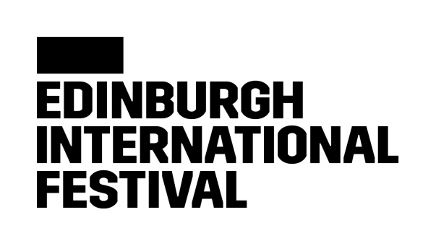

**The Festival**

The Edinburgh International Festival is an unparalleled celebration of the performing arts and an annual meeting point for peoples of all nations.

*Our vision* is simple: to provide the deepest experience of the highest quality art for the broadest possible audience.

*Our mission*: We exist to promote the exchange of ideas and deepen understanding between cultures through a global celebration of exceptional performing arts.

**Our Organisational Values**

*Enriching*: We want each person to find fulfilment and satisfaction in their work and workplace. We demonstrate flexibility, express gratitude, foster a culture of learning, and rely on teamwork.

*Professional*: We strive for excellence, not perfection. We act with integrity and accountability and expect the same from those with whom we work.

*Inclusive*: We welcome different perspectives and encourage healthy debate and discussion. We acknowledge that we might not always agree and are a stronger organisation because of our differences.

*Curious*: We are innovative and creative. We encourage evolution, embed a growth mindset, embrace experimentation, and learn from the world around us.

**Job Title** Development Assistant (full-time, permanent)

**Reports to** Director of Development

**Team** Development Department

The Edinburgh International Festival is looking for a creative, organised, and self-motivated **Development Assistant** to support the Development team in finance, communications, donor stewardship, events, and database and administration tasks to underpin the work of the fundraising team. You can help us deliver this unparalleled celebration of the performing arts, which brings some of the most exciting and creative artists working today to audiences from around the world.

Reporting to the **Director of Development**, the **Development Assistant** supports the Development Department in general administrative tasks and serves as a liaison with other departments to carry out supporter stewardship and cultivation. This is an exciting opportunity to develop your fundraising skills, contribute to the overall fundraising success of the Festival and work across many different areas of Development and the organisation. You will work as part of a collaborative team in a fast-paced environment, requiring flexibility and creativity, as well as excellent time-management, communication and administrative skills.

**Job Description**

* Serve as “superuser” of the Festival’s CRM database, Spektrix, and lead on ensuring the Development Department maximises its potential through creating distribution lists for Development communications, creating reports, and supporting the Development Department in maintaining accurate and up-to-date records.
* Maintain Development financial records, including monthly expenditure and income reconciliation between Finance & Development, raising invoices and processing pledge and donation transactions, preparing & sending donation remittances, ensuring all pledges and donations are accurately documented and processed, and working directly with the Development Director and Heads of on overall budget management.
* Support the planning and delivery of events and receptions, both outwith August and during the Festival period, including compiling invitation lists, coordinating invitations and rsvps, organising event logistics, preparing guest briefing notes for senior stakeholders, liaising with external contacts and vendors, working events and completing follow-up.
* Assist in the coordination of the Festival Launch including convening project team meetings, coordinating notes and actions, ensuring adherence to established timelines and deadlines, sending invitations and tracking rsvps, and ensuring communication of project progress is disseminated across the organisation
* Work closely with the Philanthropy Officer to support the membership programme, taking responsibility for creating mail merges, printing, and posting of membership materials, including renewals, welcome letters, and thank you communications.
* Coordinate the administration of all complimentary tickets and ticket holds issued by the Development Department, working in conjunction with the Festival’s Box Office to allocate, track, and process them, while serving as the liaison between both departments.
* Directly support the Director of Development with their portfolio of major and principal donors and partners, as well as wider support of donor stewardship and cultivation actions including drafting correspondence, carrying out research and due diligence, and preparing briefings for meetings
* General administration tasks such as coordinating and minuting Development Department meetings, ordering materials and resources, preparing templates and agendas, scheduling and travel assistance, and keeping Development team members accountable for agreed actions and progress toward strategic aims
* Represent the Festival professionally at events, functions and conferences
* Undertake any other reasonable duties assigned

**Skills Specification**

Required of all Employees

* High standard of written and verbal communication, with demonstrable ability to communicate effectively and professionally, in both written and verbal format
* Proven analytical skills; able to maintain and add to accurate budget records, and (where a role requires) managing team budget
* Manage workload and deadlines, in a way that prioritises successful delivery of individual and team objectives/projects (Time management and organisation)
* Effective interpersonal and collaboration ability; able to build rapport and work in a team with colleagues and across the organisation (Interpersonal and collaboration skills)
* Comprehensive, fast and accurate IT skills in Microsoft Word, Outlook, Excel and PowerPoint
* Passion for the performing arts, specifically in performing arts for which our festival is a world stage

Essential for the Role

* Self-motivated, proactive, and adaptable
* Exceptional attention to detail in numeracy, punctuation and grammar
* Customer-facing experience and strong customer service skills
* Confident and professional telephone manner
* Proficiency in using CRM databases
* Discretion and confidentiality

Desirable for the Role

* Particular interest in or knowledge of classical music, opera, theatre and dance
* Specific experience with Spektrix
* Knowledge of GDPR compliance and best practice
* Proficiency in using email marketing platforms
* Knowledge of responsible and effective AI use in fundraising and administrative work
* Knowledge of the UK cultural sector, its practices and supporters

**Terms and Conditions**

Working Days/Hours: Full Time

Work Pattern: 35 hours per week within standard office hours of 9.30 to 17.30, Monday to Friday, in Edinburgh. At peak times, and particularly immediately before and during the Festival, this includes working outside standard hours and at weekends. This role may have minimal travel within Scotland. Payment of overtime is not applicable to this post.

To support flexibility, we have a Smarter Working Policy which can be discussed during the recruitment process.

Contract Type: Permanent

Salary: £23,400 - £26,500

Benefits: [EIF-Employee-Benefits.pdf](https://edinburgh-festival.files.svdcdn.com/production/Documents/Policies/EIF-Employee-Benefits.pdf?dm=1749656584)

Interviews will take place 29 and 31 October.

As a result of the current immigration rules, this role is not eligible under the Skilled Worker Route. Job applicants will be expected to provide evidence of right to work in the United Kingdom or be able to obtain such.